**NAME: Suchetha Odapally**

**HALL TICKET:2203A51448**

**BATCH:12**

**AIML ASSIGNMENT-7**

Question 1:

<https://www.kaggle.com/datasets/kellistephenson/increasing-breast-cancer-awareness>

1. Read the data with pandas and find features and target variables
2. Find target variable
3. Train KNN
4. Find accuracy for different K values[2-20], plot a graph(X-axis=K, Y-axis=accuracy)

import pandas as pd

import numpy as np

import matplotlib.pyplot as plt

import seaborn as sns

%matplotlib inline

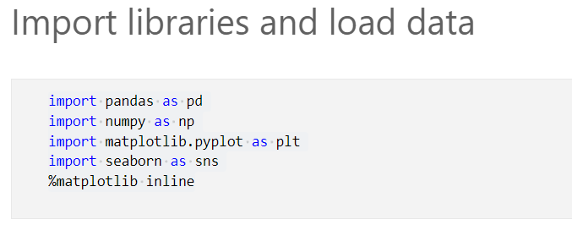

**We will build in breast cancer dataset from scikit learn.**

from sklearn.datasets import load_breast_cancer

cancer = load_breast_cancer()

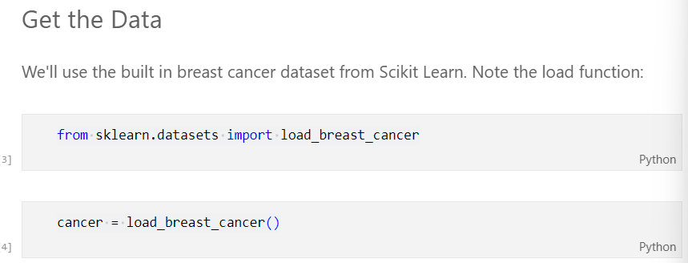

**The data set is presented in a dictionary form**

cancer.keys()

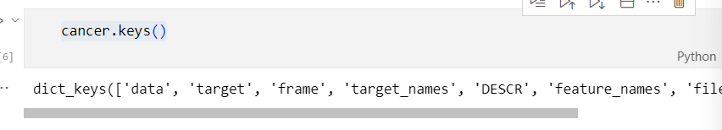

The description of features are as follows

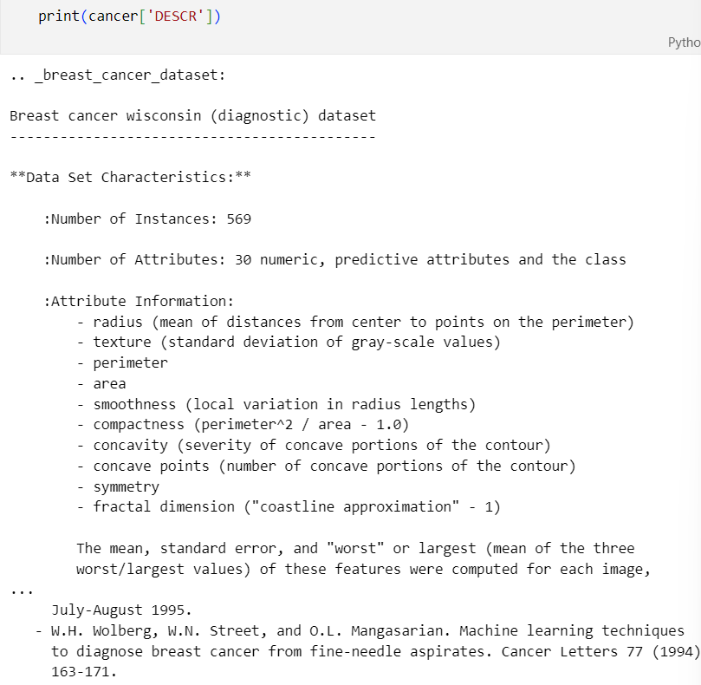

Show the feature names

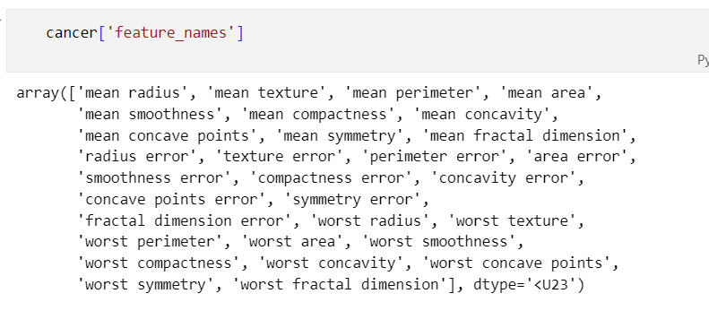

Set up the data frame

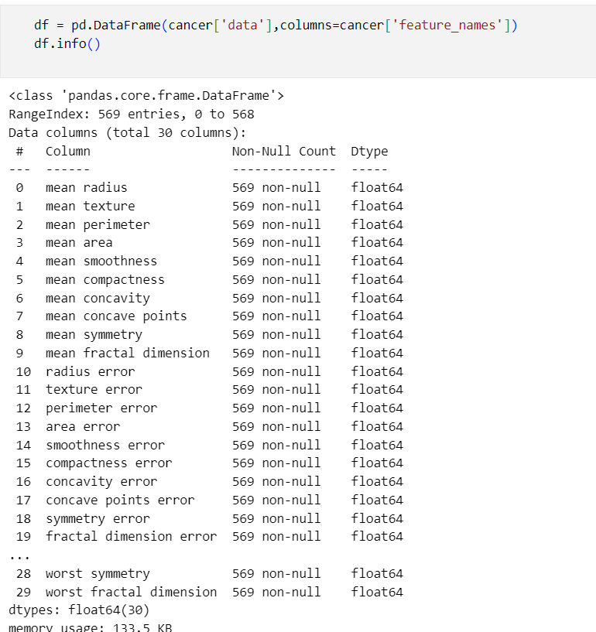

df.describe()

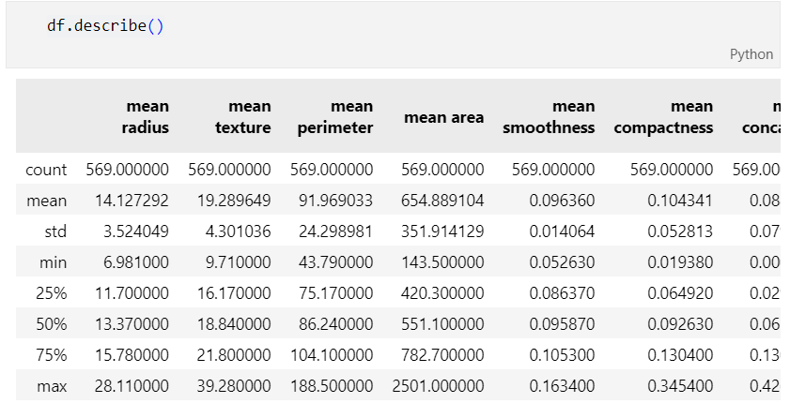

# Sum of the count of null objects in all columns of data frame

np.sum(pd.isnull(df).sum())

B. cancer['target']

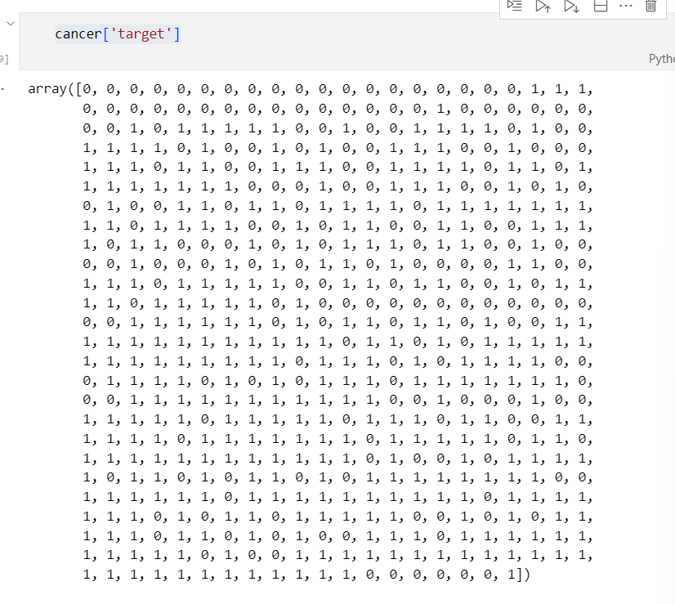

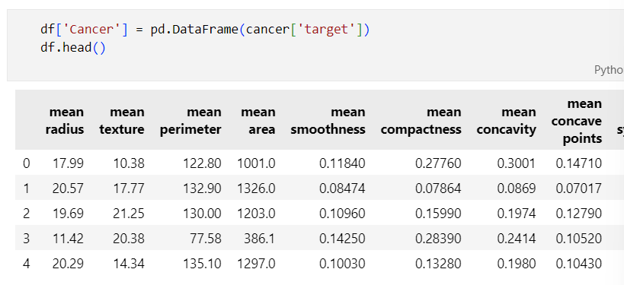

C. sns.set_style('whitegrid')

sns.countplot(x='Cancer',data=df,palette='RdBu_r')

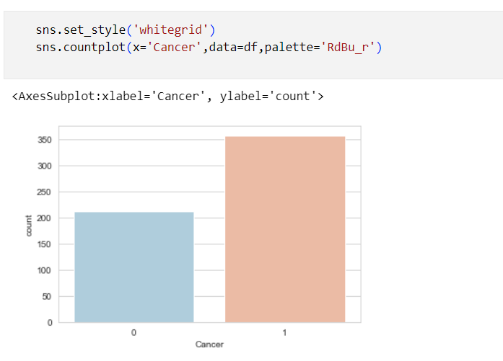

l=list(df.columns[0:10])

for i in range(len(l)-1):

    sns.boxplot(x='Cancer',y=l[i], data=df, palette='winter')

    plt.figure()

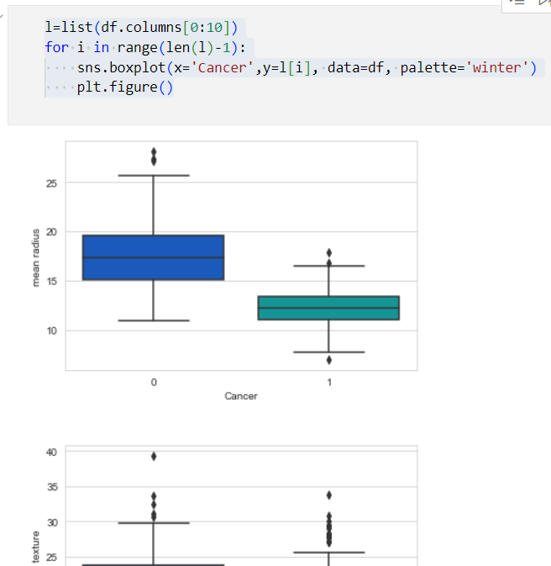

D. # Define a dataframe with only features

df_feat = df.drop('Cancer',axis=1)

df_feat.head()

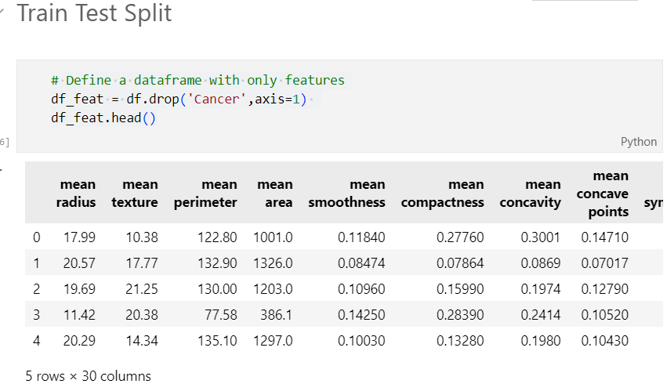

# Define a dataframe with only target results for

#cancer detection

df_target = df['Cancer']

df_target.head()

from sklearn.model_selection import train_test_split

X_train, X_test, y_train, y_test =

train_test_split(df_feat, df_target,test_size=0.30,

                 random_state=101)

X_train.head()

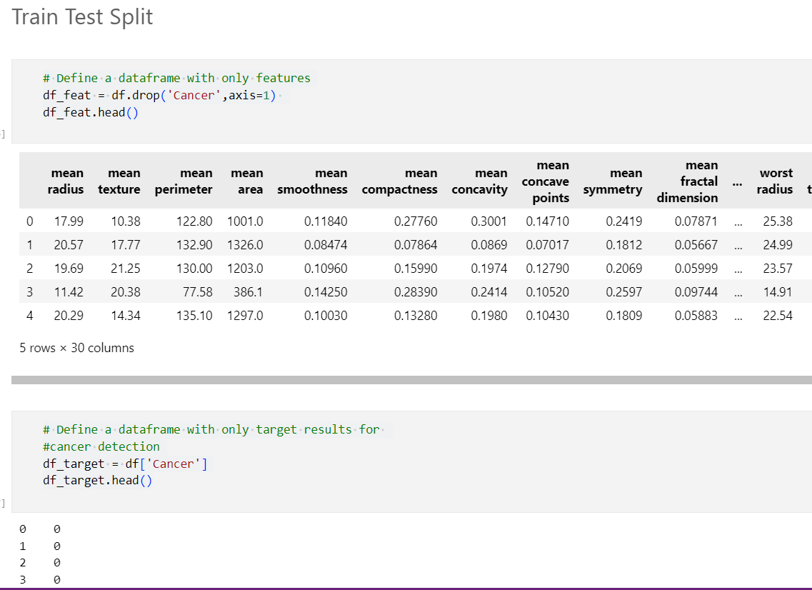

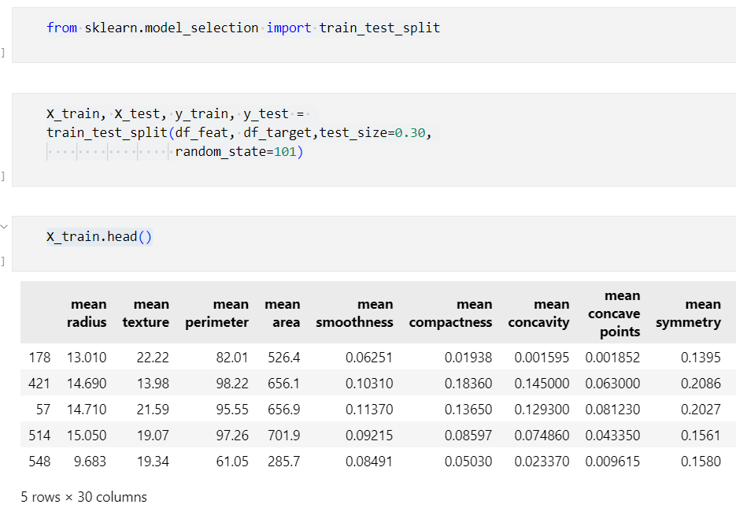

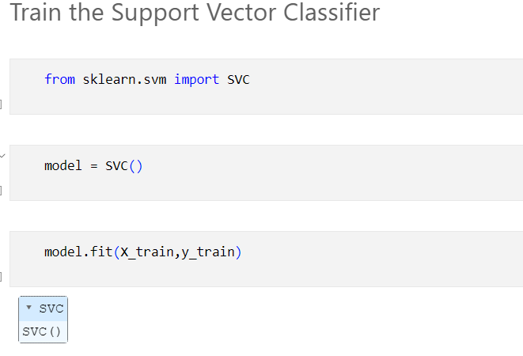

**Question 2:  
By using above data set  
• Train Decision Tree  
And find accuracy, precision, recall, f1-score  
Compare both models**

